Performance and Testing

Date
Team id | NM2025TMID02994
Project Name | LEASE MANAGEMENT
Maximum Mark

Model Performance Testing

User Creation

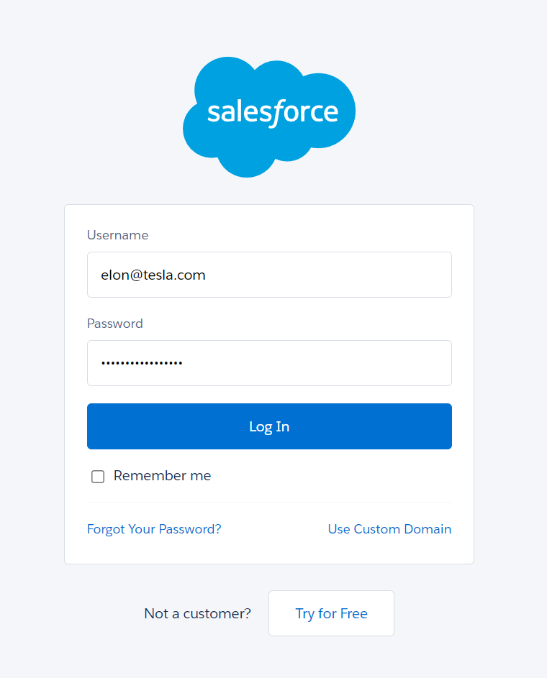

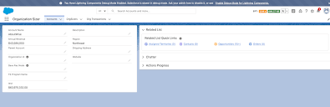

Assign Incident To User

Test Deletion

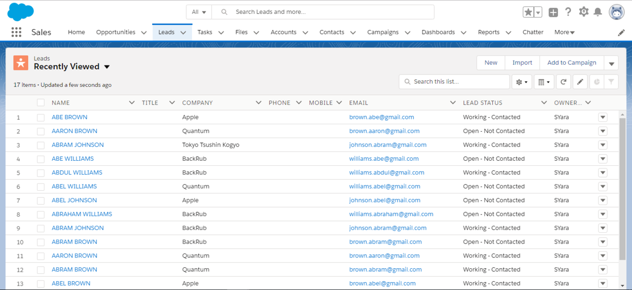

Test With Unassigned User

